Thank You Wall

We always remember you when we pray and thank God for all of you.

1 Thessalonians 1:2
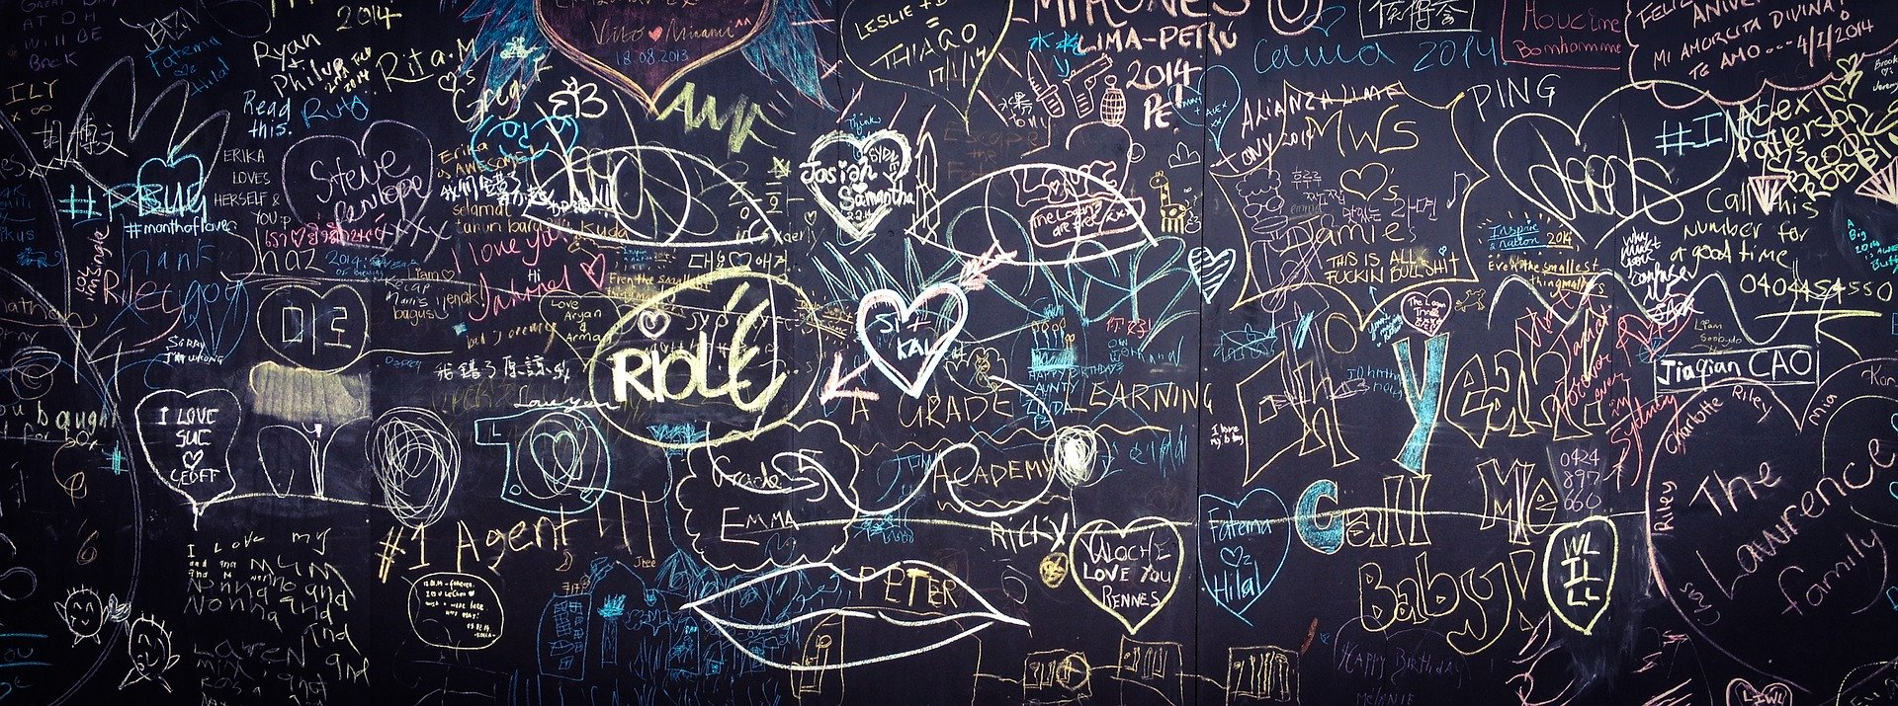

This is a simple opportunity to thank God for the people who care for others such as doctors, nurses, health care workers and our own family and friends. In some communities neighbours are looking after those who cannot leave their home to go shopping because they are self-isolating.

Equipment:
- Very large sheet of paper, a roll of backing paper would be ideal. If you have time it could be made to look like a wall with rough outline of bricks
- Felt pens or crayons
- Instruction label

Instructions:
There are lots of people who are working very hard to care for others while we are all worried about coronavirus.
Discuss with the pupils who these people might be doctors, nurses but also cleaners and delivery drivers. Perhaps the people who live in their street are looking after each other.

Write, either their name, such as Dr Smith, or their job, such as cleaner, onto the graffiti wall as a way of thanking God for them. It doesn’t matter if someone else has already written them on the wall. Lots of people can say thank you for them and the way that they care for others.

Thank You Wall.
There are lots of people who are working very hard to care for others during this time when we are worried about coronavirus: doctors, nurses and cleaners and others. Perhaps the people who live in your street or block of flats are looking after each other.

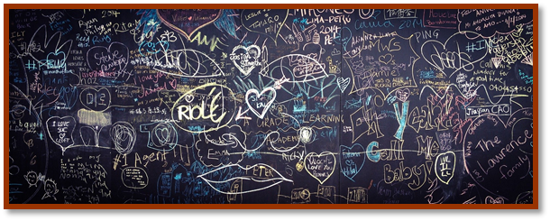
Write, either their name, or their job onto the graffiti wall as a way of thanking God for them.

