Gratitude

Jesus said: ‘ Look at the birds in the air. They don’t plant or harvest or store food in barns. But your heavenly Father feeds the birds. And you know that you are worth much more than the birds.’ Matthew 6:26

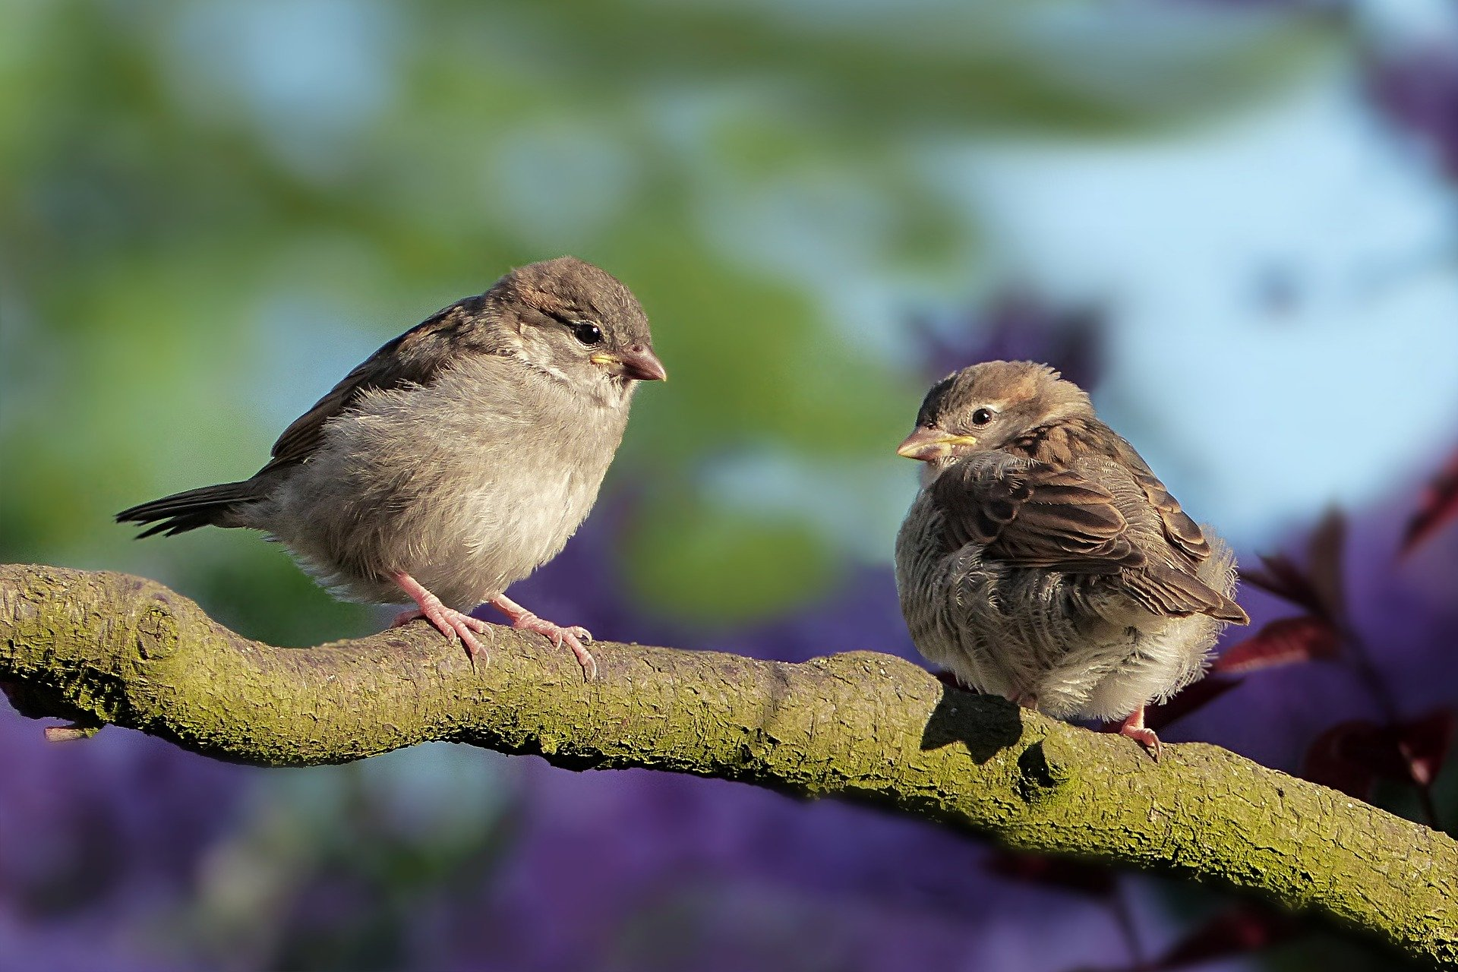
We are bombarded with frightening news at the moment but even during this worrying time there are things that we can thank God for. This prayer activity is to help the pupils to look around them and notice the good things that are around them. It is linked to birds and flowers because they are signs of spring and they also link into Jesus words about God’s care in Matthew 6: 26-34.

Equipment:
- A jug of spring flowers
- Some photos of signs of spring such birds and flowers
- Paper bird or flower shapes, an outline is attached
- Pens
- Dish for collecting the completed prayers or a large sheet of paper to stick them onto. You will need some glue sticks if you intend to do this.
- Tablecloth
- Instruction label

Instructions:
Copy the flower or bird outlines. These can be cut into rectangles there is no need to cut them out in detail.
If you are going to put the prayers in a dish lay that in the centre of the cloth.
If you are going to stick them on a large sheet of paper, make sure that you have plenty of glue sticks.
Arrange the jug of flowers as a focal point. Add photographs of signs of spring if you have them.

If you look outside you will see spring flowers and the birds building their nests. You may even have rabbits or lambs in a field near to your school. Ask the pupils what other good things they have seen in the world this week. It is good to stop worrying and think about the good things in the beautiful world around us.

In the Bible Jesus said that God cares for the birds and made wildflowers and weeds look beautiful. If he cares for the birds how much more he cares for us.

On a bird or a flower shape write or draw something good that you have seen in creation. You might like to make it a prayer.

Put your picture or prayer into the dish or stick it onto the large piece of paper.

Adults should be aware that pupils may want to talk about their worries and find it difficult to find positive things to thank God for, depending on their personal circumstances. Gently encourage them to find one good thing to notice, it will help them.

Gratitude.
If we look outside, we can see signs of spring. What have you seen in the world around you that is good this week?

Take a bird or a flower shape and on it write a thank you prayer or draw a thank you picture of something that is good.

Then put your thank you prayer or thought into the dish.

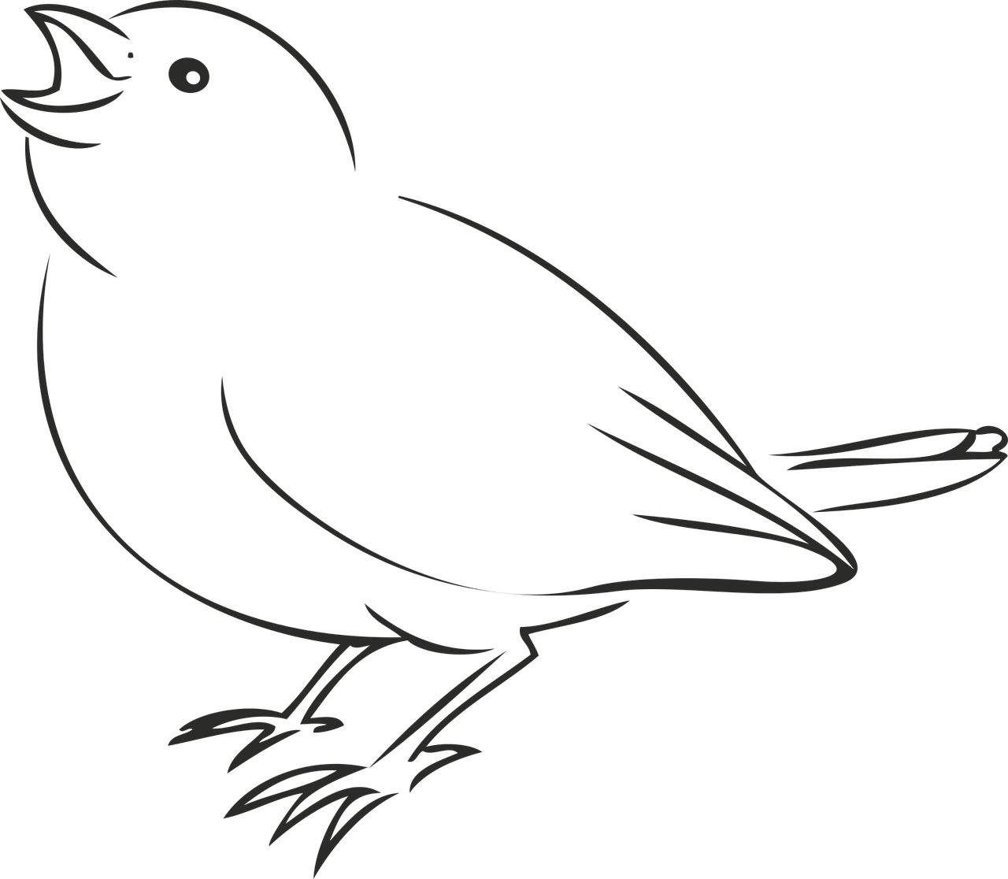 | 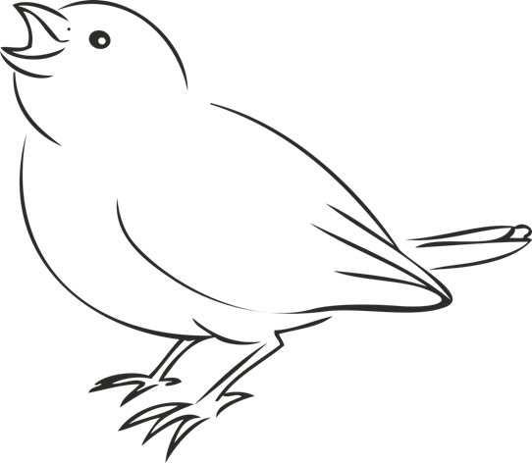
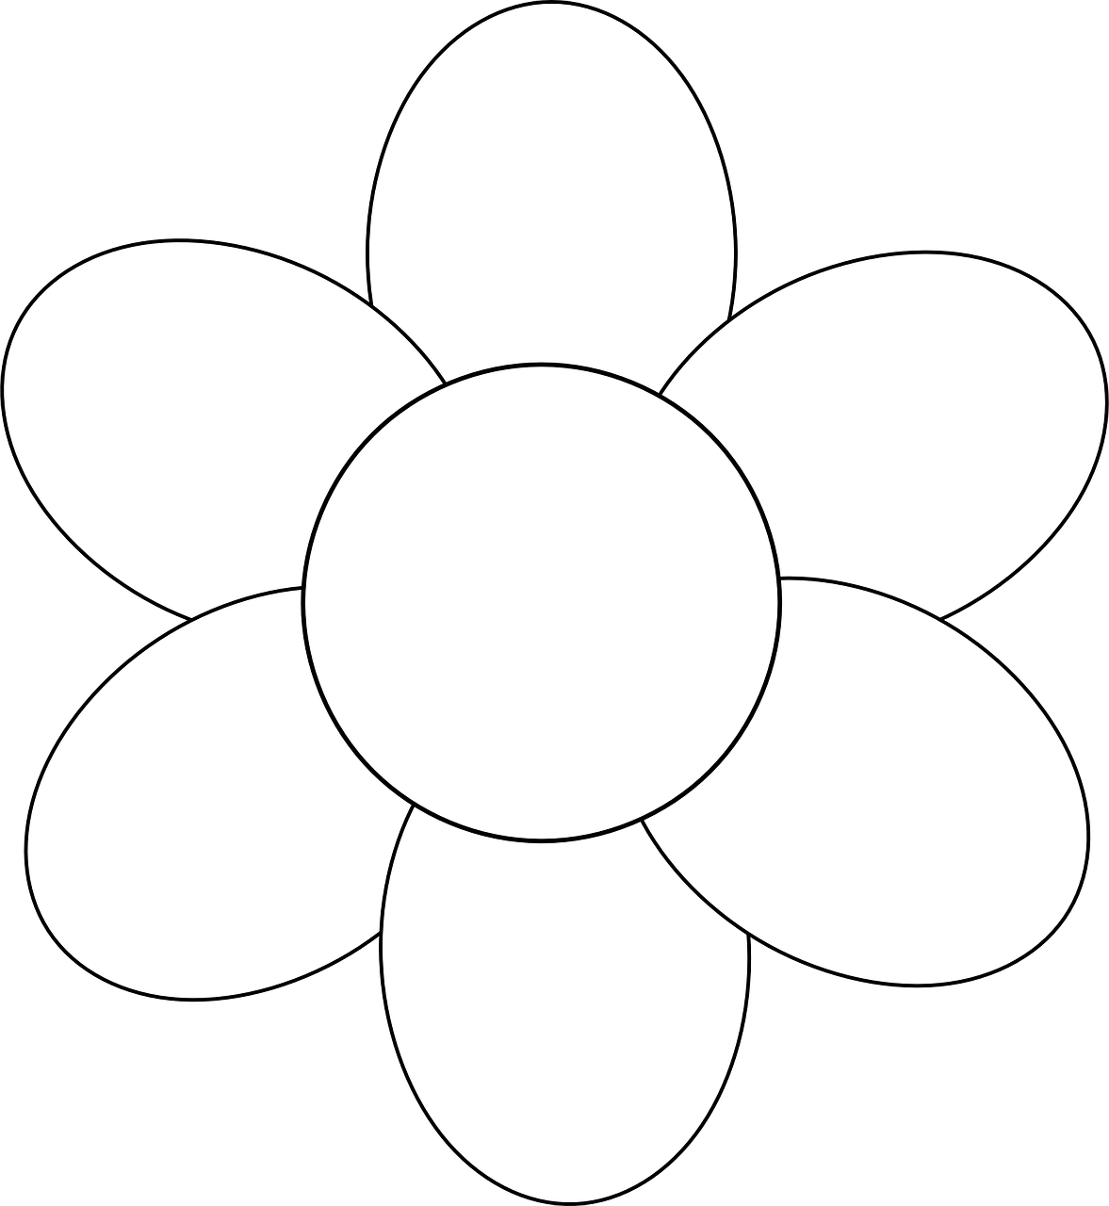 | 