Light in the darkness

The Light shines in the darkness. And the darkness has not overpowered the Light. John 1:5
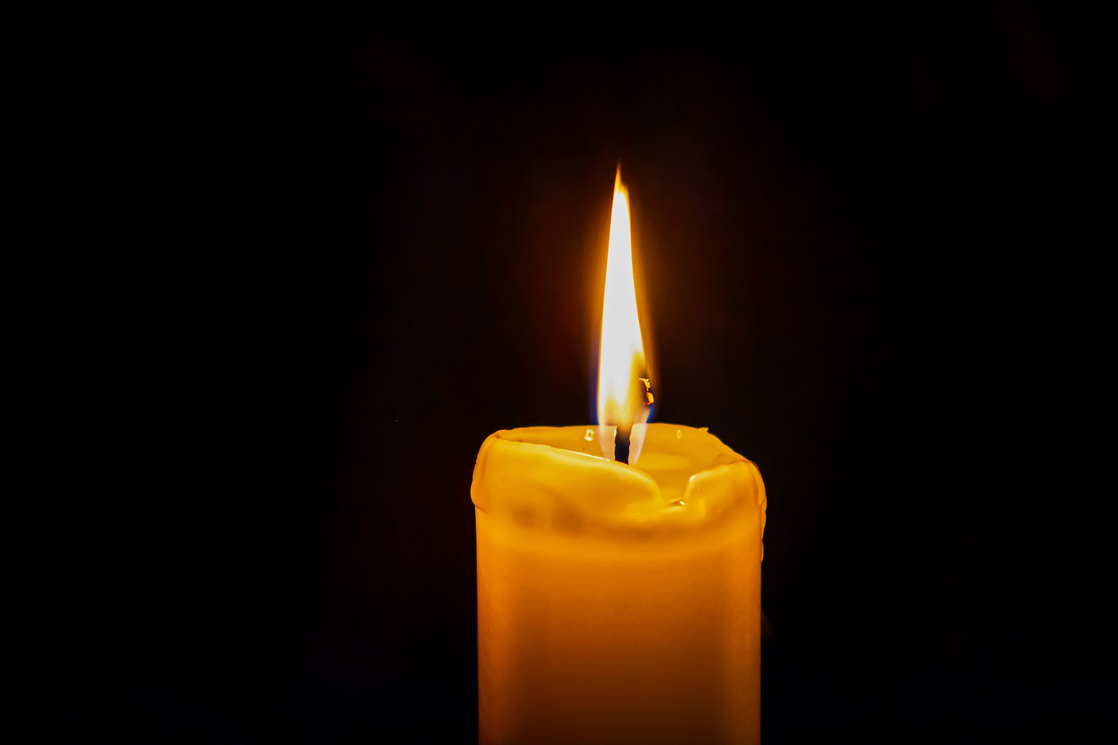
This is an opportunity for the pupils to acknowledge their anxieties and fears and give them to God. Even a small tealight makes a difference in a darkened room. This image may help pupils to see hope during this difficult time.

Equipment:
- Battery operated tealights. These are sold in some supermarkets and are available cheaply online
- If you wish to use real tea lights these should be placed on a metal tray filled with a base of sand. Use a long taper for lighting the tea lights.
- A tablecloth if using battery tea lights. Do not use if you are using naked flames.
- Basket
- Instruction label

Instructions:
Put some tealights in the middle of the cloth and the remainder in a basket at the edge.

Light one tea light and show the pupils. Even a tiny candle makes a difference in a dark room. Jesus said that He is the light of the world. When it is dark it makes us feel safe to have a light with us.

I wonder if there are things that you are feeling worried or frightened about? It is quite alright to be worried; God is with us in our worries. Him being with us is like the light that the candle made, it helps us to feel safe.

If you are feeling worried about something light a tea light and ask God to be with you and help you with that worry.

Adults should be aware that pupils may want to talk about their concerns and fears for family and friends. Some of these people could be very ill, it is important to take care not to promise that everyone will get better. Focus on God being with them and caring for them.

Light in the darkness.
Are there things that you are feeling worried or frightened about? It is quite alright to be worried; God can be with us in our worries.

If you are feeling worried about something light a tea light and ask God to be with you and help you with that worry.

